 | 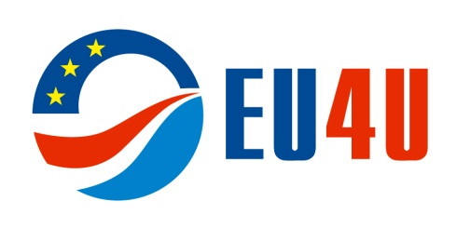 | 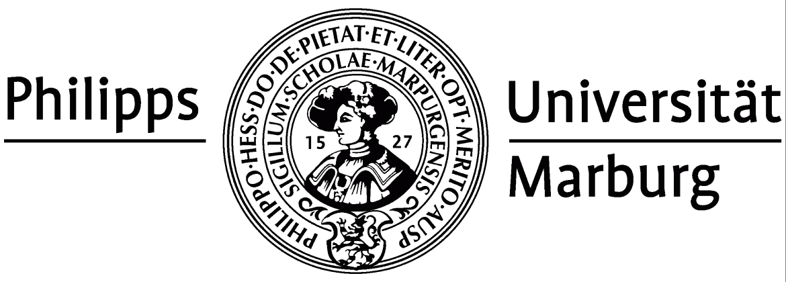
VII International Youth Summer School
«Russia & EU: Legal and Political Issues
of International Cooperation»
Kaliningrad, Russia
22 July – 9 August 2013

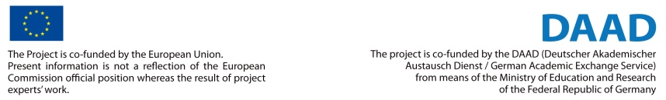

Immanuel Kant Baltic Federal University

Our University began its life as Kaliningrad State Pedagogical Institute in 1947. In 1966, it was granted the university status; in 2005 the University was renamed Immanuel Kant Federal University of Russia by a decree of the Government of the Russian Federation.
Being an innovative institution, Immanuel Kant Baltic Federal University strives to maintain and spread academic and research traditions of its predecessor – the Albertina University of Königsberg. The Albertina, one of the oldest universities in Europe, had a 460-year history. I. Kant, J. Hamann, J. Herder, F.W. Bessel, K. Jacobi, F. Linderman, А. Gurvits, D. Hilbert and H. Helmholtz taught at the Albertina University. К. Donelaitis, the founder of Lithuanian literature, delivered lectures on theology there. E.T.A. Hoffman, the famous writer and composer, attended lectures in philosophy at Albertina.
The University's greatest alumnus is Immanuel Kant, the worldfamous philosopher, who was a Russian citizen for some time. The name of I. Kant forever tied the city of Königsberg and the Albertina University with the spiritual heritage of humankind and the history of the region.
"A large city… in which the provincial councils of the government are located, which has a university … a city which, by way of rivers, has the advantages of commerce both with the interior of the country and with neighbouring and distant lands … can well be taken as an appropriate place for broadening one's knowledge of human beings as well as of the world, where this knowledge can be acquired without even traveling."
Immanuel Kant

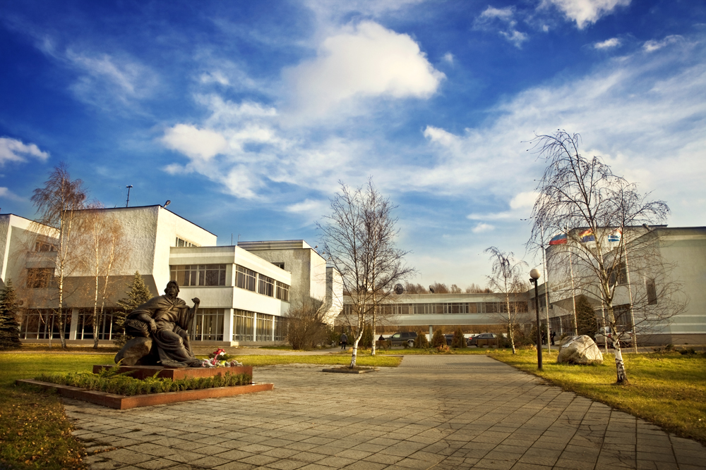
Philipps-Universität Marburg
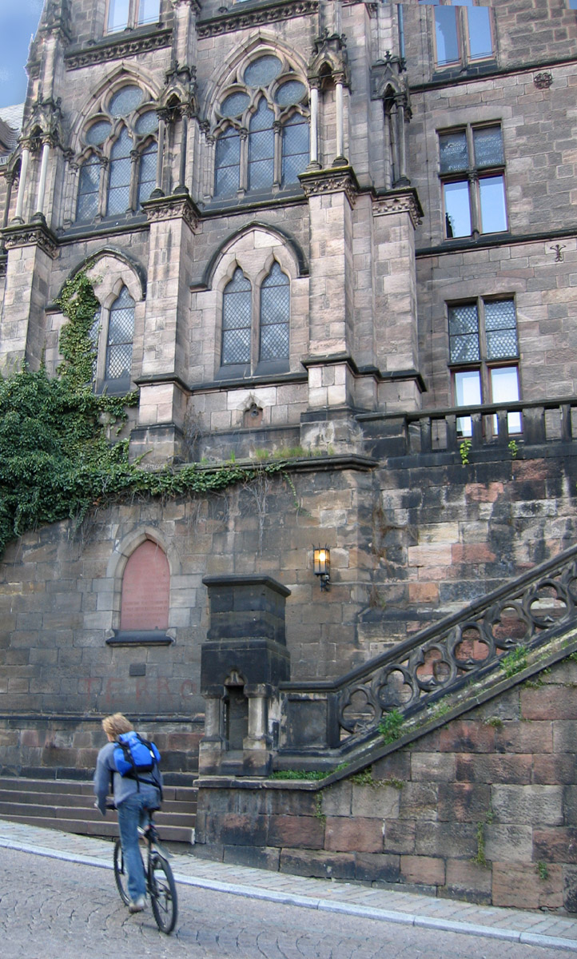
Philipps-Universität Marburg is not only a German university steeped in tradition, it is also the world’s oldest university still in existence that was founded as a Protestant institution. Since 1527, when by Landgrave Philipp the Magnanimous founded the university, it has been a place of research and teaching for nearly five centuries.
With nowadays approximately 25,000 students, the University of Marburg is one of Germany’s mid-sized universities situated in the state of Hessen. It considers itself to be a classical university offering a full range of courses with a modern and international approach in 16 faculties. Its range of various disciplines in arts, medicine, and humanities, and its experimentally challenging scientific work, constitute an ideal platform for interdisciplinary cooperation. The university relies on innovative teaching methods (with short course durations) and networked research, and offers students from all over the world more than 100 Bachelor- and Master-degree programs and subject areas, as well as many doctoral students, scientists and scholars from around the world are currently contributing to Marburg’s international focus.
The university’s success in research is well above average and highly recognized. Particular attention is payed to the interdisplinary and cutting edge, international research and to the training of young scholars and scientists. A good number of special areas of research, research groups, Graduate Schools and colleges and doctorate colleges provide excellent and often awarded and honored programs. Special interests are in the fields of humanities such as history, religion, archeology, geography, educational science, politics, social sciences, peace and conflict studies, economics and law, and in the fields of material sciences, medicine and biomedicine, neurosciences, physics, microbiology, virology, food sciences, informatics and others.
The Faculty of Law is the Marburg centre of legal training and research. It is one of the oldest continuously operating institutions of its kind in Germany. From its beginnings, since 1527, it was staffed with scholars of European recognition: For example, Friedrich Carl von Savigny (1779-1861) studied and taught here, among his students were the Brothers Wilhelm and Jacob Grimm. Today the faculty, with its 18 chairs and 2,000 full students, aims at training lawyers who are capable of coping with legal problems and transactions including their economic and social impacts, based on the knowledge of the European standards of democracy and the rule of law. The faculty provides an excellent learning environment characterized by academic freedom, international focus, cooperations with advocates, judges and enterprises, small teaching groups and, by German standards, a reasonable student-teacher ratio. With more than 100 courses and seminars the legal given curriculum leads to pass the German first state exam in Law and the university exam in addition dealing with special law areas chosen by the candidate. For students from abroad the faculty features a special Master’s programme (Magister Legum, LL.M.).
While students at Marburg University experience first rate research and teaching, they also enjoy a peaceful environment. Anonymity and overcrowded lecture halls are uncommon at Philipps-Universität. Lecturers and students cherish Marburg mainly because of its attractive historic town center, its delightful landscape and its wide range of cultural activities. In the city of Marburg, which is located on the banks of the Lahn river and has a population of almost 80,000 inhabitants, practically everything revolves around the university with its almost 25,000 students and 3,200 employees. Those studying at Marburg can complete their studies in many subjects much quicker (saving up to two and a half terms) than is possible at other German universities. This was recently confirmed by the latest survey of the German Research Council.
EU Centre at Immanuel Kant Baltic Federal University

Main objective of the EU Centre is to make the EU closer and more transparent
for the University community and all citizens of the Kaliningrad region.
Due to its geographic location the Kaliningrad region plays the leading part in the EU-Russia relations. Understanding of the importance of these relations is the key factor determining both teaching and research profile of Immanuel Kant Baltic Federal University as the leading research and education centre of the Kaliningrad region.
With its aim to facilitate the EU-Russia relations EU Centre intends to develop as a platform for discussion of EU-related questions which will gather researchers and students of IKBFU as well as its partners. Thus, a network for intellectual community open for everybody interested in the European Union will be established.

Centre Objectives:
- To promote EU related topics in education and research at IKBFU;
- To improve qualification of IKBFU teaching and academic staff in the field of EU studies, including methodology and study courses content;
- To promote a better understanding of EU among citizens of the region (NGOs’ staff, journalists, officials of both regional and municipal levels);
- To promote EU-Russia relations.

EU Centre Target Groups:
- Students;
- Researchers / Research organizations;
- Think tanks, opinion-makers and journalists, NGOs;
- Regional and local officials.

EU Centre Main Areas of Activities:
- European Law;
- Political Science and International Relations;
- Baltic Sea Region Studies;
- Mass-media and PR.

www.kantiana.ru/eu4u
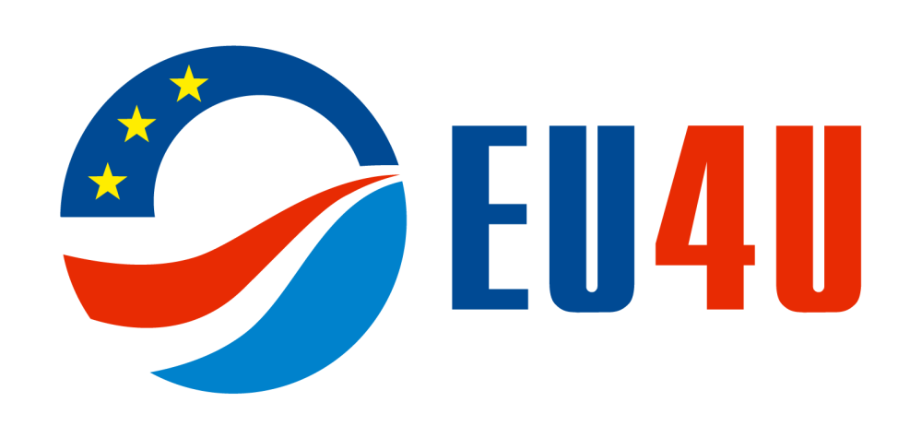
International Youth Summer School «Russia & EU: Legal and Political Issues of International Cooperation»

 | July 22, Monday. Opening Session. Auditorium Aquarium.
9.30-10.30 | Opening of the Summer School.  Welcoming speeches:  Prof. Dr. Andrey Klemeshev, Rector of Immanuel Kant Baltic Federal University  Dr. Rolf Friedrich Krause, Consul General of the Federal Republic of Germany in Kaliningrad  Mr. Vaclav Stankevic, Consul General of the Republic of Lithuania in Kaliningrad  Mr. Zbigniew Zaremba, Deputy Head of Mission, Consulate General of the Republic of Poland in Kaliningrad  Prof. Dr. Hans-Detlef Horn, Dean of the Law Faculty at the Philipps-Universität Marburg  Dr. Igor Zhukovski, Vice-Rector for International Affairs, Immanuel Kant Baltic Federal University  Prof. Dr. Oleg Zayachkovskiy, Director of the Institute of Law, Immanuel Kant Baltic Federal University  Dr. Anna Barsukova, Head of the EU Centre, Immanuel Kant Baltic Federal University
10.30 – 11.30 | Lecture. Introduction to Russia and EU Relations  Dr. Vadim Voinicov, Assistant Professor, Department for International and European Law, Coordinator of European Law Section of EU Centre, IKBFU
11.30 – 13.00 | Discussion. Priorities of the Kaliningrad Region Development: International Context  Stanislav Voskresensky, Deputy Presidential Plenipotentiary Envoy to the Northwestern Federal District, Ex- sherpa of Russian delegation in G8 and G20
13.00 – 14.00 | Welcoming lunch at the cafe «Valenki» (7-9 Nevskogo Str.)
15.00 – 17.00 | Tram excursion around the city. Meeting point: Vasilevskogo Square.

TRAM IN KALININGRAD
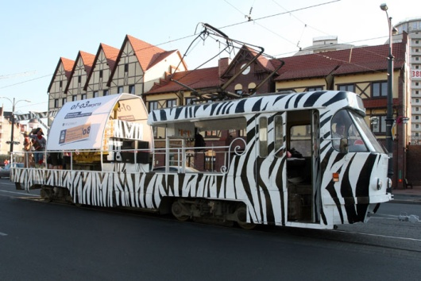
The Kaliningrad tram system is the only operating tram system in the region and the oldest one in the territory of modern Russia (operates since 1895). Kaliningrad tram is one of the two surviving tram systems in Russia with a meter gauge (the other one is in Pyatigorsk).
Today residents and visitors of the city have a unique opportunity to see and learn about the history of Kaliningrad and Königsberg from the window of a Kaliningrad tram.
Every Sunday at 16:00 all summer long a special tram tour starts from the Main (South) Railway Station: Main Railway Station - Kaliningrad Hotel - Pobedy Square -Vasilevskogo Square- Frunze Str. - Kaliningrad Art Gallery – Octyabrskaya Str. – Bagrationa Str. - Leninsky Prospect–Main Railway Station.
The Friedland Gate museum guides elaborated a unique tour round the historic city center, during which they speak about the past, present and planned future of Kaliningrad, as well as answer all imaginable and unimaginable sightseers’ questions.
International Relations and Political Science Section

WEEK I
July 23, Tuesday. Auditorium 202.
10.00 – 11.20 | Lecture. Role of the “Soft Power” in Russia - EU Cooperation – Ms. Ksenia Smertina
11.30 – 13.00 | Lecture. Role of the “Soft Power” in Russia - EU Cooperation – Ms. Ksenia Smertina
13.00 – 14.00 | Lunch at the cafe «Valenki» (7-9 Nevskogo Str.)
15.30 – 17.00 | Meetings in the framework of case studies. Representation of the Ministry of Foreign Affairs in Kaliningrad (17 Kirova Str.). Meeting with Mr. Pavel Mamontov, Representative of the Ministry of Foreign Affairs in Kaliningrad. Discussion. Role of the Kaliningrad region in the foreign policy of Russia and aspects of the diplomatic activity in the Kaliningrad region. Meeting point: cafe “Valenki” at 15.00.
 | July 24, Wednesday. Auditorium 202.
10.00 – 11.20 | Seminar. Role of the “Soft Power” in Russia - EU Cooperation – Ms. Ksenia Smertina
11.30 – 13.00 | Seminar. Role of the “Soft Power” in Russia - EU Cooperation – Ms. Ksenia Smertina
13.00 – 14.00 | Lunch at the cafe «Valenki» (7-9 Nevskogo Str.)
15.30 – 17.00 | Meetings in the framework of case studies. Consulate General of the Republic of Lithuania (133 Proletarskaja Str.). Meeting with Mr. Vatslav Stankevic, Consul General of the Republic of Lithuania in Kaliningrad. Discussion. Role of the Kaliningrad region in the foreign policy of the Republic of Lithuania and aspects of the diplomatic activities in the Kaliningrad region. Meeting point: cafe “Valenki” at 15.00.
 | July 25, Thursday. Auditorium 202.
10.00 – 11.20 | Lecture. Introduction to the EU Institutional System – Dr. Philippe Perchoc
11.30 – 13.00 | Lecture. Introduction to the EU Institutional System – Dr. Philippe Perchoc
13.00 – 14.00 | Lunch at the cafe «Valenki» (7-9 Nevskogo Str.)
15.30 – 17.00 | Meetings in the framework of case studies. Meeting with Ms. Alla Ivanova, Minister-Head of the Agency of the International and Interregional Relations of the Government of the Kaliningrad region. Discussion. Role of the international cooperation in the Kaliningrad region development. (Auditorium 202)
 | July 26, Friday. Auditorium 202.
11.00 – 12.20 | Meetings in the framework of case studies. Meeting with Mr. Marek Golkowski, Consul General of the Republic of Poland in Kaliningrad. Discussion. Role of the Kaliningrad region in the foreign policy of the Republic of Poland. (Auditorium 202)
13.00 – 14.00 | Lunch at the cafe «Valenki» (7-9 Nevskogo Str.)
14.00 – 15.00  15.15 – 18.00 | Test. Introduction to the EU Institutional System – Dr. Philippe Perchoc  S(t)imulation game. EU Negotiation Skills – Dr. Philippe Perchoc
 | July 27, Saturday. Social programme.
12.00 – 15.00 | Tour to the Curonian Spit. Picnic. Meeting point: University Main Building, 14 Nevskogo Str.
 | July 28, Sunday. Social programme. Optional.
09.00 – 16.00 | Tour to Baltiysk (ships parade). More information: http://www.kantiana.ru/eu4u
WEEK II
July 29, Monday. Auditorium 202.
10.00 – 11.20 | Lecture. The German Factor in EU and Russia Relations – Prof. Dr. Peter W. Schulze
11.30 – 13.00 | Lecture. The German Factor in EU and Russia Relations – Prof. Dr. Peter W. Schulze
13.00 – 14.00 | Lunch at the cafe «Valenki» (7-9 Nevskogo Str.)
15.30 - 17.00 | Meetings in the framework of case studies. Kaliningrad Regional Duma (17 Kirova Str). Meeting with deputies of the Kaliningrad Regional Duma. Discussion. International interparliamentary cooperation between the Kaliningrad Regional Duma and regional parliaments in Germany, Poland and the Seimas of the Lithuanian Republic. Meeting point: restaurant Valenki at 15.00.
 | July 30, Tuesday. Auditorium 202.
10.00 – 11.20 | Test. The German Factor in EU-Russia relations - Prof. Dr. Peter W. Schulze
11.30 – 13.00 | Lecture. The EU and Eurasia: competitors, enemies or possible partners? - Prof. Dr. Peter W. Schulze
13.00 – 14.00 | Lunch at the cafe «Valenki» (7-9 Nevskogo Str.)
 | July 31, Wednesday. Auditorium 202.
10.00 – 11.20 | Lecture. Common External Policy and EU Security Policy and Cooperation with Russia – Dr. Sergey Utkin
11.30 – 13.00 | Lecture. Common External Policy and EU Security Policy and Cooperation with Russia – Dr. Sergey Utkin
13.00 – 14.00 | Lunch at the cafe «Valenki» (7-9 Nevskogo Str.)
15.30 - 17.00 | Meetings in the framework of case studies. Meeting with Ms. Elena Romanova and Ms. Olga Maksimova, Kaliningrad Chamber of Commerce and Industry. Discussion. Social Responsibility in Business in the Framework of Cooperation within the EU. (Auditorium 202)
 | August 1, Thursday. Auditorium 202.
10.00 – 11.20 | Seminar. Common External Policy and EU Security Policy and Cooperation with Russia - Dr. Sergey Utkin
11.30 – 13.00 | Test. Common External Policy and EU Security Policy and Cooperation with Russia - Dr. Sergey Utkin
13.00 – 14.00 | Lunch at the cafe «Valenki» (7-9 Nevskogo Str.)
15.30 – 17.00 | Meetings in the framework of case studies. Meeting with Georgy Dykhanov, MBA, Director General of the Kaliningrad Consulting Centre “Business Expert”. Role of the Kaliningrad region in European business. Auditorium 202.
 | August 2, Friday. Auditorium 202.
10.00 – 11.20 | Lecture. Does Constitution matter? Establishing Democratic Institutions and Practices in Central and Eastern Europe countries: Comparative Analysis - Dr. Yan Vaslavskiy
11.30 – 13.00 | Seminar. Does Constitution matter? Establishing Democratic Institutions and Practices in Russia - Dr. Yan Vaslavskiy
13.00 – 14.00 | Lunch at the cafe «Valenki» (7-9 Nevskogo Str.)
14.30 – 17.30 | Lecture. European values vs Eurasian values – Prof. Dr. Oleg Barabanov  August 3, Saturday. Social programme.
08.30 – 18.00 | Tour to the Lake Vištytis. Picnic. Meeting point: University Main Building, 14 Nevskogo Str.
WEEK III
August 5, Monday. Auditorium 202.
10.00 – 12.00 | Lecture. Panel discussion. Q&A session. ‘The EU’s trade policy’ - Lord Green
13.00 – 14.00 | Lunch at the cafe «Valenki» (7-9 Nevskogo Str.)
 | August 6, Tuesday. Auditorium 202.
10.00 – 11.20 | Lecture. EU and Russia in Global Affairs - Dr. Igor Istomin
11.30 – 13.00 | Lecture. EU and Russia in Global Affairs - Dr. Igor Istomin
13.00 – 14.00 | Lunch at the cafe «Valenki» (7-9 Nevskogo Str.)
 | August 7, Wednesday. Auditorium 202.
10.00 – 11.20 | Seminar. Applied Analysis of International Affairs - Dr. Igor Istomin
11.30 – 13.00 | Seminar. Applied Analysis of International Affair - Dr. Igor Istomin
13.00 – 14.00 | Lunch at the cafe «Valenki» (7-9 Nevskogo Str.)
 | August 8, Thursday. Auditorium 202.
10.00 – 11.20 | Lecture. Russian and EU Approaches to the General Issues of Modern International Relations – Dr. Alexandra Khudaykulova
11.30 – 13.00 | Lecture. Russian and EU Approaches to the General Issues of Modern International Relations – Dr. Alexandra Khudaykulova
13.00 – 14.00  15.00 – 17.00 | Lunch at the cafe «Valenki» (7-9 Nevskogo Str.)  Presentation of case studies.
 | August 9, Friday. Closing of the Summer School. Auditorium 202.
10.00 – 11.20 | Lecture. European and Russian Interpretation of Security Issues: Comparative Approach - Dr. Alexandra Khudaykulova
11.30 – 13.00 | Lecture. European and Russian Interpretation of Security Issues: Comparative Approach - Dr. Alexandra Khudaykulova
17.00 – 19.00 | Closing ceremony of the Summer School. Awarding of certificates. Dinner at the Solnechny Kamen Restaurant (Vasilevskogo Square)

LAW Section
WEEK I
 | July 23, Tuesday. Auditorium Aquarium.
08.30 – 09.50 | Europäisches Wirtschaftsrecht (D2) - Prof. Dr. Christoph Vedder
10.00 – 11.20 | Europäisches Wirtschaftsrecht (D2) - Prof. Dr. Christoph Vedder
11.40 – 13.00 | Bezüge des Staatsrechts zum Europa- und Völkerrecht (D1) - Prof. Dr. Hans-Detlef Horn
13.00 – 14.00 | Lunch at the cafe «Valenki» (7-9 Nevskogo Str.)
14.00 – 15.20 | Human Rights Law in Europe – ECHR (E2) - Prof. Dr. Dr. h.c. mult. Gilbert Gornig
 | July 24, Wednesday. Auditorium Aquarium.
08.30 – 09.50 | Bezüge des Staatsrechts zum Europa- und Völkerrecht (D1) - Prof. Dr. Hans-Detlef Horn
10.00 – 11.20 | Bezüge des Staatsrechts zum Europa- und Völkerrecht (D1) - Prof. Dr. Hans-Detlef Horn
11.40 – 13.00 | Europäisches Wirtschaftsrecht (D2) - Prof. Dr. Christoph Vedder
13.00 – 14.00 | Lunch at the cafe «Valenki» (7-9 Nevskogo Str.)
14.00 – 15.20  15.40 – 16.50 | Europäisches Wirtschaftsrecht (D2) - Prof. Dr. Christoph Vedder  Human Rights Law in Europe – ECHR (E2) - Prof. Dr. Dr. h.c. mult. Gilbert Gornig
 | July 25, Thursday. Auditorium Aquarium.
08.30 – 09.50 | Human Rights Law in Europe – ECHR (E2) - Prof. Dr. Dr. h.c. mult. Gilbert Gornig
10.00 – 11.20 | Human Rights Law in Europe – ECHR (E2) - Prof. Dr. Dr. h.c. mult. Gilbert Gornig
11.40 – 13.00 | Europäisches Wirtschaftsrecht (D2) - Prof. Dr. Christoph Vedder
13.00 – 14.00 | Lunch at the cafe «Valenki» (7-9 Nevskogo Str.)
14.00 – 15.20  15.40 – 16.50 | Europäisches Wirtschaftsrecht (D2) - Prof. Dr. Christoph Vedder  Bezüge des Staatsrechts zum Europa- und Völkerrecht (D1) - Prof. Dr. Hans-Detlef Horn
 | July 26, Friday. Auditorium Aquarium.
08.30 – 09.50 | Europäisches Wirtschaftsrecht (D2) - Prof. Dr. Christoph Vedder
10.00 – 11.20 | Europäisches Wirtschaftsrecht (D2) - Prof. Dr. Christoph Vedder
11.40 – 13.00 | Bezüge des Staatsrechts zum Europa- und Völkerrecht (D1) - Prof. Dr. Hans-Detlef Horn
13.00 – 14.00  14.00 – 15.20  15.40 – 16.50 | Lunch at the cafe «Valenki» (7-9 Nevskogo Str.)  Bezüge des Staatsrechts zum Europa- und Völkerrecht (D1) - Prof. Dr. Hans-Detlef Horn  Human Rights Law in Europe – ECHR (E2) - Prof. Dr. Dr. h.c. mult. Gilbert Gornig  July 27, Saturday. Social programme. Curonian Spit.
12.00 – 15.00 | Tour to the Curonian Spit. Picnic. Meeting point: University Main Building, 14 Nevskogo Str.
15.00 – 16.00 | Lunch at the cafe «Valenki» (7-9 Nevskogo Str.)
 | July 28, Sunday. Social programme.
09.00 – 16.00 | Tour to Baltiysk (ships parade) Optional
WEEK II
 | July 29, Monday. Auditorium Aquarium.
08.30 – 09.50 | Europäisches Wirtschaftsrecht (D2) - Prof. Dr. Christoph Vedder
10.00 – 11.20 | Europäisches Wirtschaftsrecht (D2) - Prof. Dr. Christoph Vedder
11.40 – 13.00 | Das europaeische Recht des geistigen Eigentums (D3) - Dr. Daniel Matthias Klocke
13.00 – 14.00 | Lunch at the cafe «Valenki» (7-9 Nevskogo Str.)
14.00 – 15.20  15.40 – 16.50 | International Economic Law – WTO (E1) - Prof. Dr. Markus Kotzur  Human Rights Law in Europe – ECHR (E2) - Prof. Dr. Dr. h.c. mult. Gilbert Gornig
 | July 30, Tuesday. Auditorium Aquarium.
08.30 – 09.50 | Human Rights Law in Europe – ECHR (E2) - Prof. Dr. Dr. h.c. mult. Gilbert Gornig
10.00 – 11.20 | Human Rights Law in Europe – ECHR (E2) - Prof. Dr. Dr. h.c. mult. Gilbert Gornig
11.40 – 13.00 | Europäisches Wirtschaftsrecht (D2) - Prof. Dr. Christoph Vedder - EXAM
13.00 – 14.00 | Lunch at the cafe «Valenki» (7-9 Nevskogo Str.)
14.00 – 15.20  15.40 – 16.50 | Das europaeische Recht des geistigen Eigentums (D3) - Dr. Daniel Matthias Klocke  International Economic Law – WTO (E1) - Prof. Dr. Markus Kotzur
 | July 31, Wednesday. Auditorium Aquarium.
08.30 – 09.50 | Europäisches Wirtschaftsrecht (D2) - Prof. Dr. Christoph Vedder
10.00 – 11.20 | Human Rights Law in Europe – ECHR (E2) - Prof. Dr. Dr. h.c. mult. Gilbert Gornig
11.40 – 13.00 | Human Rights Law in Europe – ECHR (E2) - Prof. Dr. Dr. h.c. mult. Gilbert Gornig
13.00 – 14.00 | Lunch at the cafe «Valenki» (7-9 Nevskogo Str.)
14.00 – 15.20  15.40 – 16.50 | International Economic Law – WTO (E1) - Prof. Dr. Markus Kotzur  Das europaeische Recht des geistigen Eigentums (D3) - Dr. Daniel Matthias Klocke
 | August 1, Thursday. Auditorium Aquarium.
08.30 – 09.50 | International Economic Law – WTO (E1) - Prof. Dr. Markus Kotzur
10.00 – 11.20 | International Economic Law – WTO (E1) - Prof. Dr. Markus Kotzur
11.40 – 13.00 | Human Rights Law in Europe – ECHR (E2) - Prof. Dr. Dr. h.c. mult. Gilbert Gornig - EXAM
13.00 – 14.00 | Lunch at the cafe «Valenki» (7-9 Nevskogo Str.)
14.00 – 15.20 | Das europaeische Recht des geistigen Eigentums (D3) - Dr. Daniel Matthias Klocke
 | August 2, Friday. Auditorium Aquarium.
08.30 – 09.50 | Das europaeische Recht des geistigen Eigentums (D3) - Dr. Daniel Matthias Klocke
10.00 – 11.20 | Das europaeische Recht des geistigen Eigentums (D3) - Dr. Daniel Matthias Klocke
11.40 – 13.00 | International Economic Law – WTO (E1) - Prof. Dr. Markus Kotzur
13.00 – 14.00  14.00 – 15.20 | Lunch at the cafe «Valenki» (7-9 Nevskogo Str.)  Human Rights Law in Europe – ECHR (E2) - Prof. Dr. Dr. h.c. mult. Gilbert Gornig
 | August 3, Saturday. Social programme.
08.30 – 18.00 | Tour to the Lake Vištytis. Picnic. Meeting point: University Main Building, 14 Nevskogo Str.
WEEK III
August 5, Monday. Auditorium Aquarium.

08.30 – 09.50 | Bezüge des Staatsrechts zum Europa- und Völkerrecht (D1) - Prof. Dr. Hans-Detlef Horn
10.00 – 11.20 | Bezüge des Staatsrechts zum Europa- und Völkerrecht (D1) - Prof. Dr. Hans-Detlef Horn
11.40 – 13.00 | Das europaeische Recht des geistigen Eigentums (D3) - Dr. Daniel Matthias Klocke
13.00 – 14.00  14.00 – 15.20 | Lunch at the cafe «Valenki» (7-9 Nevskogo Str.)  International Economic Law – WTO (E1) - Prof. Dr. Markus Kotzur
 | August 6, Tuesday. Auditorium Aquarium.
08.30 – 09.50 | Das europaeische Recht des geistigen Eigentums (D3) - Dr. Daniel Matthias Klocke
10.00 – 11.20 | Das europaeische Recht des geistigen Eigentums (D3) - Dr. Daniel Matthias Klocke
11.40 – 13.00 | International Economic Law – WTO (E1) - Prof. Dr. Markus Kotzur
13.00 – 14.00  14.00 – 15.20 | Lunch at the cafe «Valenki» (7-9 Nevskogo Str.)  Bezüge des Staatsrechts zum Europa- und Völkerrecht (D1) - Prof. Dr. Hans-Detlef Horn
 | August 7, Wednesday. Auditorium Aquarium.
08.30 – 09.50 | International Economic Law – WTO (E1) - Prof. Dr. Markus Kotzur
10.00 – 11.20 | International Economic Law – WTO (E1) - Prof. Dr. Markus Kotzur
11.40 – 13.00 | Bezüge des Staatsrechts zum Europa- und Völkerrecht (D1) - Prof. Dr. Hans-Detlef Horn
13.00 – 14.00  14.00 – 15.20 | Lunch at the cafe «Valenki» (7-9 Nevskogo Str.)  Das europaeische Recht des geistigen Eigentums (D3) - Dr. Daniel Matthias Klocke
 | August 8, Thursday. Auditorium Aquarium.
08.30 – 09.50 | Das europaeische Recht des geistigen Eigentums (D3) - Dr. Daniel Matthias Klocke - EXAM
10.00 – 11.20 | Bezüge des Staatsrechts zum Europa- und Völkerrecht (D1) - Prof. Dr. Hans-Detlef Horn - EXAM
11.40 – 13.00 | International Economic Law – WTO (E1) - Prof. Dr. Markus Kotzur - EXAM
13.00 – 14.00 | Lunch at the cafe «Valenki» (7-9 Nevskogo Str.)
 | August 9, Friday. Auditorium Aquarium.
08.30 – 09.50 | Bezüge des Staatsrechts zum Europa- und Völkerrecht (D1) - Prof. Dr. Hans-Detlef Horn
10.00 – 11.20 | International Economic Law – WTO (E1) - Prof. Dr. Markus Kotzur
11.40 – 13.00 | Das europaeische Recht des geistigen Eigentums (D3) - Dr. Daniel Matthias Klocke
17.00 – 19.00 | Dinner at the Solnechny Kamen Restaurant
KEYNOTE Speakers

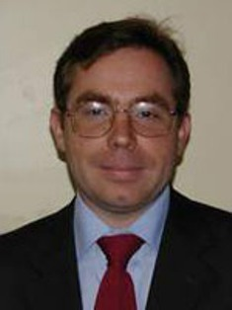 | Prof. Dr. Oleg Barabanov  Head of Department of EU Politics, MGIMO-University, Professor, School of World Economics and Global Politics, Higher School of Economics  E-mail: drolegbarabanov@gmail.com
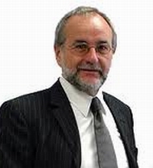 | Prof. Dr. Gilbert Gornig  Institute of Public Law, University of Marburg  E-mail: sekretariat@gornig.com
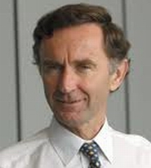 | Lord Stephen Green  Minister of State for Trade and Investment, UK  E-mail: mpst.green@bis.gsi.gov.uk
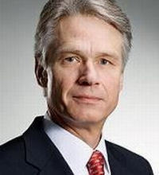 | Prof. Dr. Hans-Detlef Horn  Dean, Faculty of Law, University of Marburg  E-mail: hans-detlef.horn@jura.uni-marburg.de
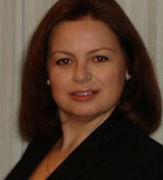 | Dr. Alexandra Hudaykulova  Vice-Rector for Educational Program Development, Associate Professor, Department of World Political Processes, MGIMO-University  E-mail: khudaykulova@mgimo.ru
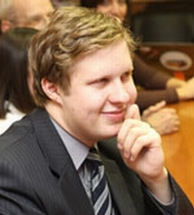 | Dr. Igor Istomin  Project Coordinator, European Studies Institute, Lecturer, Department of Applied Analysis of International Issues, MGIMO-University  E-mail: iaistomin@gmail.com
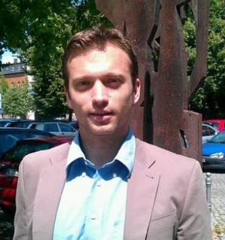 | DR. DANIEL MATTHIAS KLOCKE  Faculty of Law, Martin-Luther-University Halle-Wittenberg  E-mail: daniel.klocke@jura.uni-halle.de
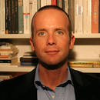 | Prof. Dr. Markus Kotzur  Faculty of Law, University of Hamburg  E-mail: markus.kotzur@jura.uni-hamburg.de
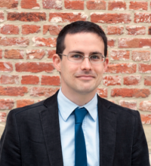 | Dr. Philippe PERCHOC  Academic Assistant at the College of Europe, University of Leuven (Belgium), Science Po Paris (France)  E-mail: philippe.perchoc@coleurope.eu
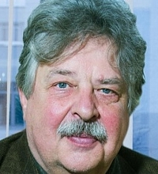 | Prof. Dr. Peter W. Schulze  Professor h.c. of Political Science, International Relations and Russian Studies, Georg August University of Goettingen  E-mail: Schulze-Lemgow@t-online.de
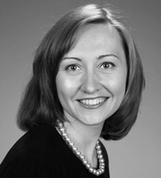 | Ksenia Smertina  Head of the Office for International Accreditations and Rankings, MGIMO-University  E-mail: ksenia.smertina@gmail.com
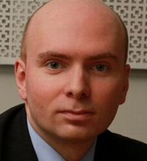 | DR. Sergey Utkin  Head of the Section for Political Issues of European Integration, Department of European Political Studies, Institute of World Economy and International Relations, RAS  E-mail: sv.utkin@gmail.com
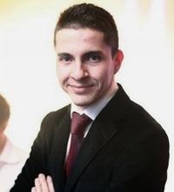 | Dr. Yan Vaslavskiy  Associate Professor, Department for Political Theory; Executive Director, School of Government and International Affairs, MGIMO-University  E-mail: y.vaslavskiy@inno.mgimo.ru
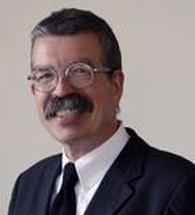 | Prof. Dr. Christoph Vedder  Faculty of Law, University of Augsburg  E-mail: Christoph.Vedder@Jura.Uni-Augsburg.de
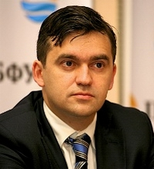 | Mr. Stanislav Voskresensky  Deputy Presidential Plenipotentiary Envoy to the Northwestern Federal District, Ex- sherpa of Russian delegation in G8 and G20
Organizing committee

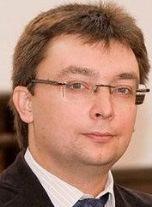 | Dr. Igor Zhukovsky  Vice-Rector for International Affairs, Associate Professor, Department for Political Science, Coordinator of PS&IR Section of EU Centre, Director of the Centre for Polish Studies, IKBFU  Member of the Russian-Polish Council on Cooperation between the Kaliningrad region and Polish Border Voevodships  E-mail: izhukovskii@kantiana.ru
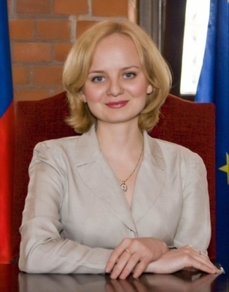 | Dr. Anna BARSUKOVA  Associate Professor, Department for Political Science, Head, International Office, Director of the EU Centre, IKBFU  E-mail: abarsukova@kantiana.ru
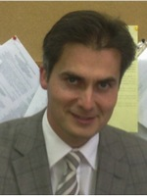 | Dr. Vadim VOINIKOV  Assistant Professor, Department for International and European Law, Coordinator of European Law Section of EU Centre, IKBFU  Member of the Board of the Interregional Public Organization Association for European Research, Chairman of the Kaliningrad regional Department of the Association for European Research  E-mail: voinikov@yandex.ru
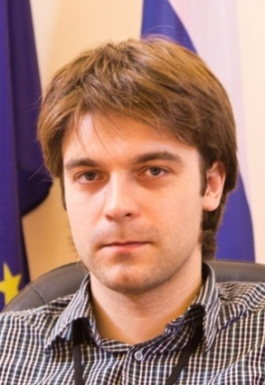 | Vladimir BALOBAEV  Assistant Lecturer, Political Science Department, Assistant at the Political Science and International Relations Secton of the EU Centre, Expert of the Centre for Polish Studies, IKBFU  E-mail: vbalobaev@gmail.com
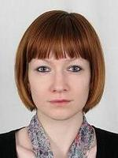 | Anastasia MALININA  Director, Centre for International and European Law, Law Institute, Assistant at the European Law Unit of the EU Centre, IKBFU  E-mail: an.malinina@gmail.com
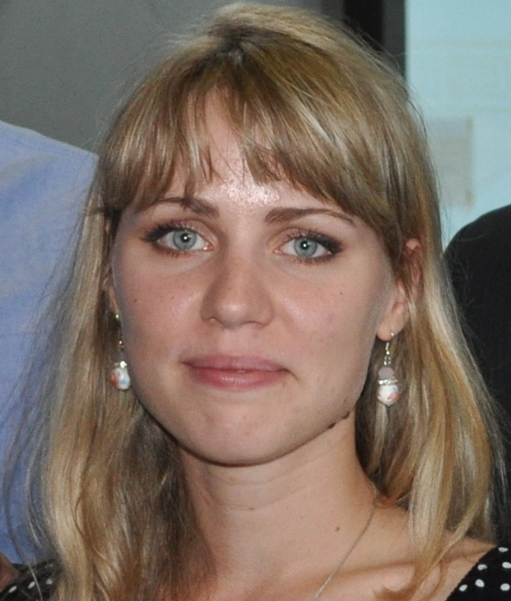 | Katerina DEVYATOVSKAYA  Coordinator for Information Support of Summer School  E-mail: kdevyatovskaya@kantiana.ru
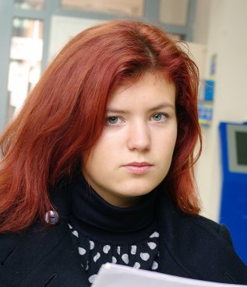 | Daria STUPAKOVA  Assistant of PS&IR Section of Summer School  E-mail: dstupakova@kantiana.ru
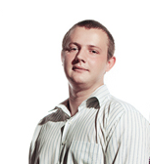 | Alexey PETRENKO  Assistant of Law Section, responsible person for social programme of Summer School  E-mail: alex.petrenko39@gmail.com

KALININGRAD
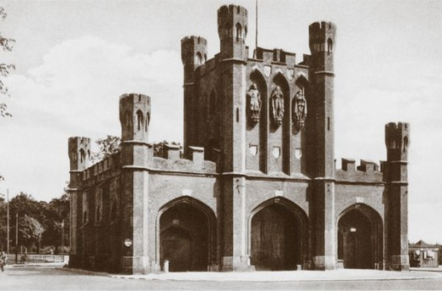
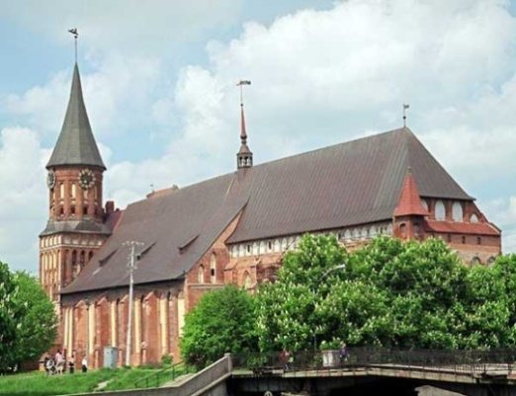
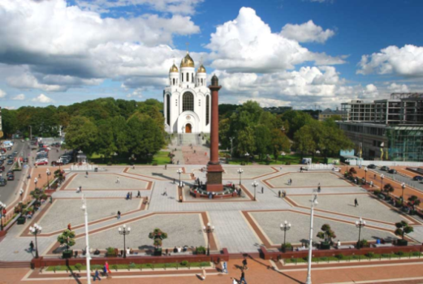
The historical name of the city is Königsberg. The castle Königsberg was founded on the 1st of September 1255 by the grandmaster of the Teutonic order Peppo Ostern von Wertgaint and Czech king Przhemysl II Otakar on the remnants of the Prussian fort Twangste (Tuwangste, Tvankste). In 1544 the Albertina University was opened, named in honor of Duke Albert. Among the famous people born here are the great philosopher Immanuel Kant, the outstanding German writer Ernst Theodor Amadeus Hoffmann, the prominent figures in German culture and science philosopher Johann Gottfried von Herder and Johann Gottlieb Fichte, naturalist Karl Ernst von Baer, composer Richard Wagner, mathematicians David Hilbert and Hermann Minkowski, artist Käthe Kollwitz, sculptor Hermann Brachert, political scientist Hannah Arendt and many others. During World War II, in August 1944 Königsberg was severely damaged by British bombardments and in April 1945 stormed by the Soviet troops. Today Kaliningrad is a dynamically developing trade and industrial center of Russia’s westernmost region. The historical legacy of many centuries, which has garnered interest in the past years, successfully intertwines with signs of the third millennium, creating a unique combination, which attracts guests from all over the world.

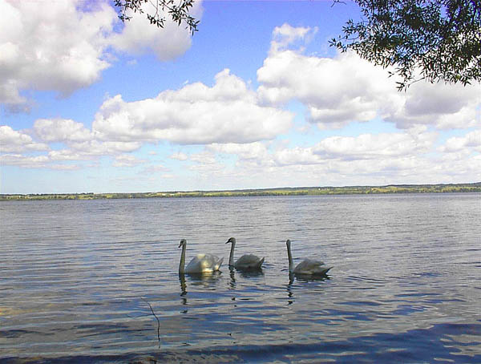
Lake Vištytis is a lake on the border between Lithuania (Vilkaviškis district) and Russia (Kaliningrad Oblast). Prior to World War II it marked part of the border between Germany (East Prussia) and Lithuania.
The small Lithuanian town of Vištytis on the northern shore was named after the lake. On the Lithuanian side, the lake and its environs are protected by Vištytis Regional Park. The lake has 15 inflows, but only one river, the Pissa, tributary to Pregolya, flows from this lake.
Lake Vištytis covers an area of 17.83 km2 (6.88 sq mi), of which 5.44 km2 (2.10 sq mi) belongs to Lithuania. This is a marked increase over 0.4 km2 (0.15 sq mi) that belonged to Lithuania before ratification of the Russian–Lithuanian border treaty in 2003. On occasion, high winds or broken equipment can force tourist boats to the opposite shore. Even if unintentional, such incidents constitute illegal border crossings and can lead to sanctions from the border guards.
Before the 2003 treaty, the border ran along the waterline of the beaches on the Lithuanian side, so anyone paddling in the water was technically crossing into Russia.
Sometimes the lake is used for smuggling goods, usually cigarettes, across the border.
National Park “Curonian Spit”
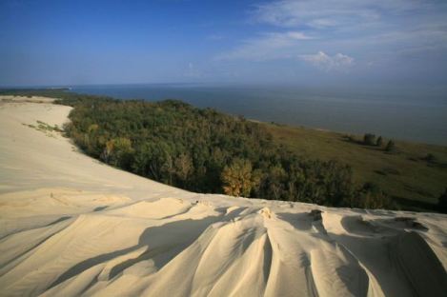
There are places on the Earth, always making you wonder and admire. One of these unique parts of our land is considered to be the Curonian Spit - a narrow strip of land between the Baltic Sea and the Curonian Lagoon, which stretches 97 miles from Zelenogradsk to Klaipeda. If you come to the Kaliningrad region for one day and you have time to visit only one attraction, do not waste time thinking - you simply must visit the Curonian Spit. It is no accident that the Curonian Spit National Park is included in the register of protected natural heritage.
Five thousand years ago winds and currents the Baltic Sea have created a strip of sand separating fresh and salt water. The narrowest part of the Spit is 800 just meters and the widest - 2 kilometers, its total length is 98 km. Since 1987 the Curonian Spit is a national park, and in 2000 it entered the UNESCO World Heritage Register. But these cold hard facts and figures will not be able to convey the ineffable charm inherent in this unique miracle of nature. There is no industry, no major settlements on the Curonian Spit. It is a place where just a nature reigns!
Web-site: www.park-kosa.ru

Kaliningrad Museums
- Kaliningrad Regional Historical and Art Museum –21 Klinicheskaya Str., phone number +7 4012 45-39-02, museum is opened from Tuesday to Sunday from 11:00 till) 19:00.
- Cathedral (Evangelical chapel and Orthodox chapel, Museum of the Cathedral and Museum of Immanuel Kant are situated in the Cathedral now) - museums is (-are) opened everyday from 9:00 till 17 :00.
- Museum of the World Ocean. Wharf of Bagramian, phone number +7 4012 46-63-02, the Museum is opened from Wednesday to Sunday from 11:00 till 18:00.
- Museum of Amber. Square of Marshal Vasilevsky, phone number +7 4012 46-06-13, museum is opened from Tuesday to Sunday from 10:00 till 18:00.
- Kaliningrad Art Gallery – Moskovsky Prospect 60/62, phone number +7 4012 46-71-66, gallery is opened from Tuesday to Sunday from 11:00 till 19:00.
- Blindage. Universitetskaya Street, phone number +7 4012 43-05-93, museum is opened everyday from 10:00 till 17:00.
Sights of the city:
- Freedland gates – Kalinina prospect.
- Brandenburg gates – Bagration Street.
- Zakheim gates – at the intersection of Moskovsky prospect and Litovsky val Street.
- Royal gates – Litovsky val Street.
- Fort No 5 – Sovetsky prospect.
- Monument to Immanuel Kant – Universitetskaya Street
- Sculpture “Fighting bisons” – Mira prospect.
- Monument to Friedrich Shiller – Teatralnaya Street
- Monument to Baron Münchhausen – Pobedy prospect (Central Park).
Places where you can inexpensively eat with pleasure
General:
Food hall in the shopping centre | Leninskiy prospect, 30
First (with Wi-Fi) | Leninskiy prospect, 81 (near the Kaliningrad Hotel)  Theatralnaya str., 30
McDonald`s | Shopping centre “Europe” – Pobedy Square
Italian cuisine (pizzeria):
Papasha Beppe | Leninsky prospect, 20/26, near the shopping centre Plaza
Mama mia | Universitetskaya str., 13 A. Nevskogo str., 34 B, near the dormitory
Don Chento | Victoria Supermarkets
Japanese cuisine:
Yakitoriya | Leninskiy prospect, 18
Territoriya sushi | Theatralnayal Str., 30 (SC “Europe”, 2 floor)
Sushi - More | Leninskiy prospect, 81
Riso | Leninskiy prospect, 30, (SC “Europe”)  Leninskiy prospect, 42в
Restaurant-brewery:
Kropotkin | Ground floor of the SC “Europe”
Pivovar | A. Nevskovo Str., 137B
Khmel | Pobedy square, 10, SC “Clover”
Coffe and tea houses:
Mirovoy kofe | Bagrationa Str., 99
Confectioner shops:
Pani Eva | Theatralnaya str., 23, Proletarian str., 72а, Mira prospect, 102, Kosmonavta Leonova Str., 25
Kruassan-kafe | A. Nevskovo Str., 24 Mira prospect, 23/27 Leninskiy prospect. 79 (near the SC “Merkuriy”)

Pharmacies near the dormitory:
Formula zdorovya:
- Leninskiy prospect, 67
- Frunze Str., 17-21

Emergency telephone numbers:
- 01 – fire emergency
- 02 – police
- 03 – ambulance service

Additional information
Taxi
We recommend to hire a cab by calling one of the following taxi-companies:
- Taxi “City” +7 4012 602602
- Taxi “Navigator” +7 4012 555525
- “Kaliningrad Taxi Station” +7 4012 585858
- Taxi “Around the world” +7 4012 563030
- Taxi +7 4012 555 000
An approximate price of a taxi trip in Kaliningrad varies between 100 and 200 roubles, depending on the distance traveled and time of the day.
In case you have any questions feel free to ask us.
We will do our best to help you!
Contact persons:
Anna Barsukova | (Coordinator) | mob. +7-906-217-95-10
Anastasia Malinina | (Coordinator Law Section) | mob. +7-921-852-13-66
Daria Stupakova | (Assistant of PS&IR Section) | mob. +7-952-112-29-05
Aleksey Petrenko | (Assistant of Law Section) | mob. +7-911-498-60-47

Our partners:

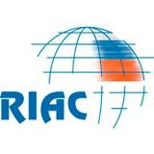 | 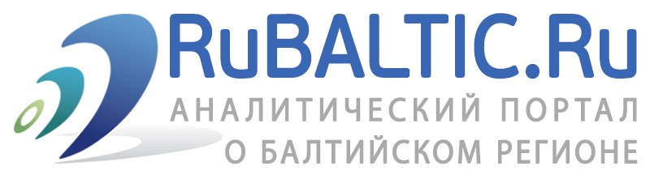
russiancouncil.ru | rubaltic.ru

ПРОГРАММА Международной молодежной школы
«Россия & ЕС: правовые и политические
аспекты международных отношений»
Калининград, Россия
22 ИЮЛЯ - 9 АВГУСТА 2013

Ответственный за выпуск В.А. Балобаев

Тираж 100 экз.

Отпечатано в Издательстве
Балтийского федерального университета имени Иммануила Канта
236041, г. Калининград, ул. А. Невского, 14

